STEP 1: GO TO CONSUMER & SEARCH CONSUMER


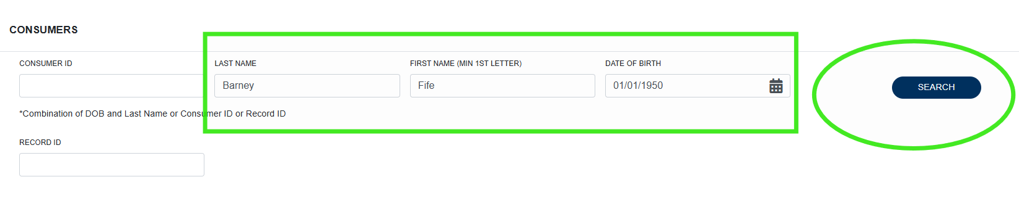
STEP 2: CLICK ON THE CONSUMERS NAME IN BLUE*

STEP 3: EXPAND THE CASES TAB
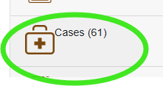
STEP 4: FIND MOST RECENT ADW ASSESSMENT CASE - LIKLEY LABELED ADW (MEMBER ACTIVE LEVEL ____) OR IT COULD SAY VERIFY ME_ASSESSMENT SCHEDULED
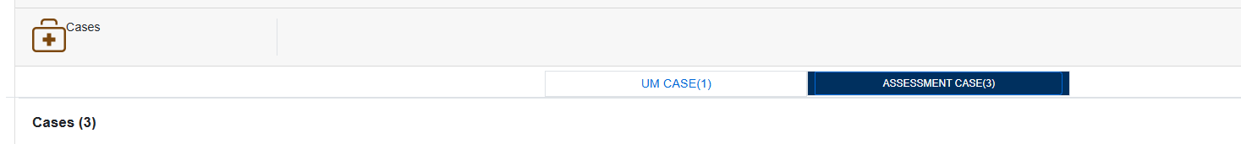
STEP 5: CLICK INSIDE THE CASE
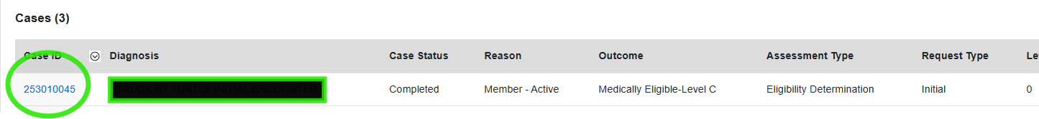
STEP 6: FIRST TAB IS CASE OVERVIEW – FIND DOCUMENTS AND EXPAND.
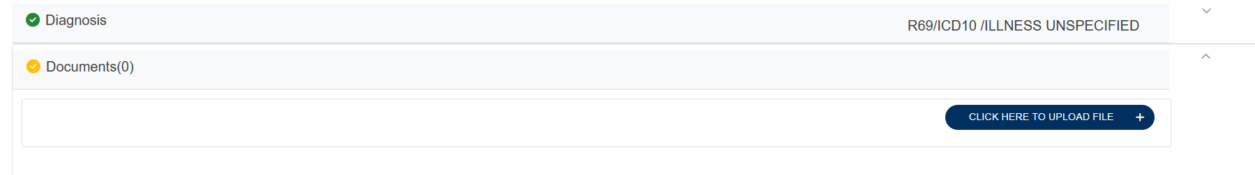
FIND THE FILE & ATTACH

