Job Aid Title: WV ADW Provider: Creating Annual Assessment Case | Job Aid Number: WV.ADW.ANG.JA.008
Date Published: 11/14/2025 | Approved by: Melody Cottrell, Kim Sang
References: Atrezzo Assessment User Guide
Purpose: This job aid outlines step-by-step instructions for providers to create an annual assessment case in the portal.

Consumer Search
Click the Consumers tab
Search for the consumer using Consumer ID or Last Name and Date of Birth  Click Search | 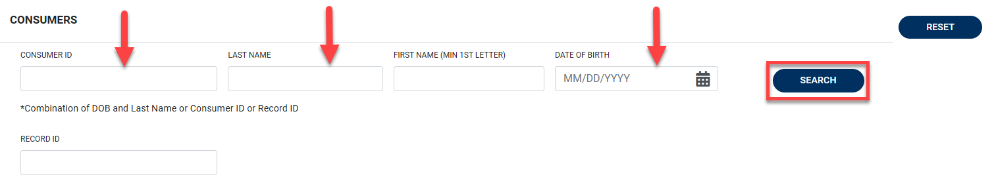
From the search results, click the name hyperlink to open the consumer’s profile | 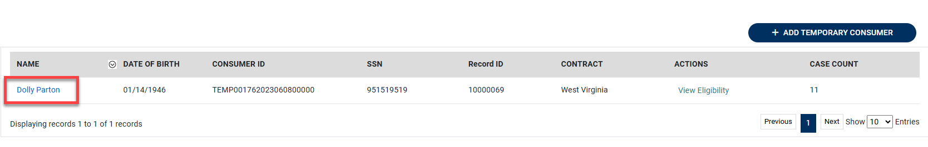
Create Assessment Case
Click Create Case |  | 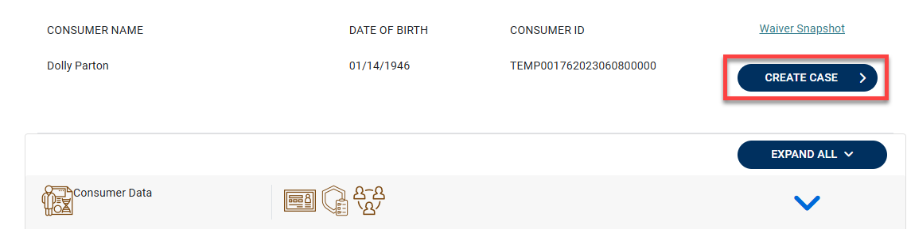

When prompted:  Select Case Type: Assessment  Case Contract: WV ADW  Note: Assessment Case Type pre-populates with ADW  Click Go To Consumer Information to proceed | 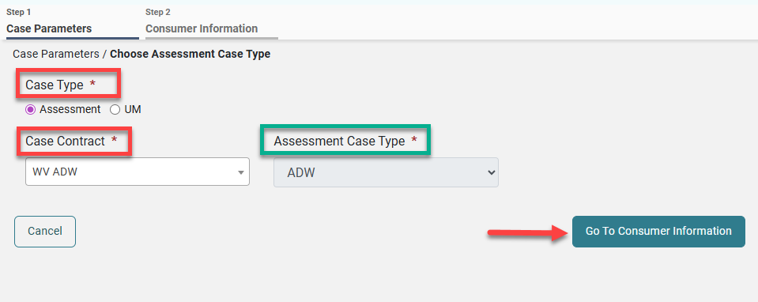
Review the consumer’s details for accuracy  Click Create Case to proceed | 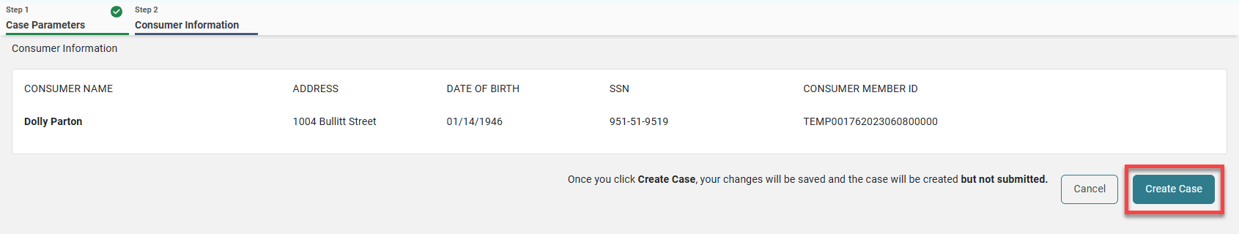
Add Diagnoses:  Scroll to the Diagnosis section and expand it using the arrow  Click Add Diagnosis  Select Code Type: ICD10  Enter either diagnosis code or description, then click Search | 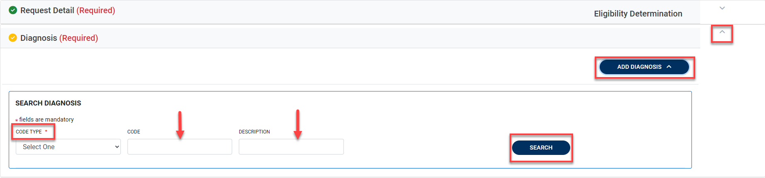
Check the box next to the correct code | 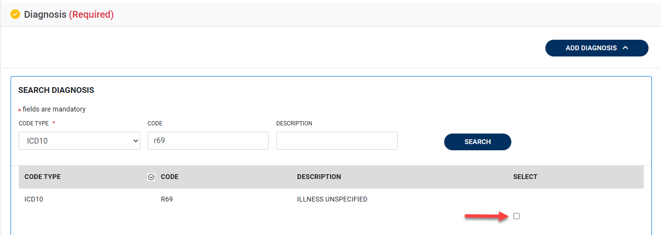
Enter Request Details:  Scroll to the Request Detail section and expand it using the arrow  Set Request Type: Re-evaluation  Assessment Type: Eligibility Determination | 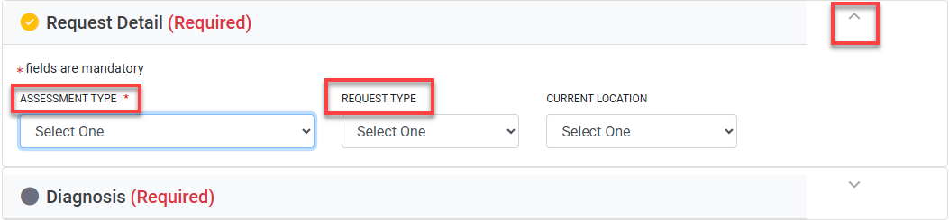
A pop-up will confirm the questionnaire has been added  Click OK to dismiss | 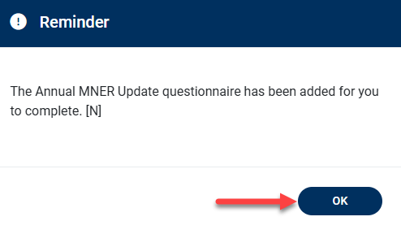
Complete the Questionnaire:  Scroll to the Questionnaires section and expand it using the arrow  Click the hyperlink to access the Questionnaire | 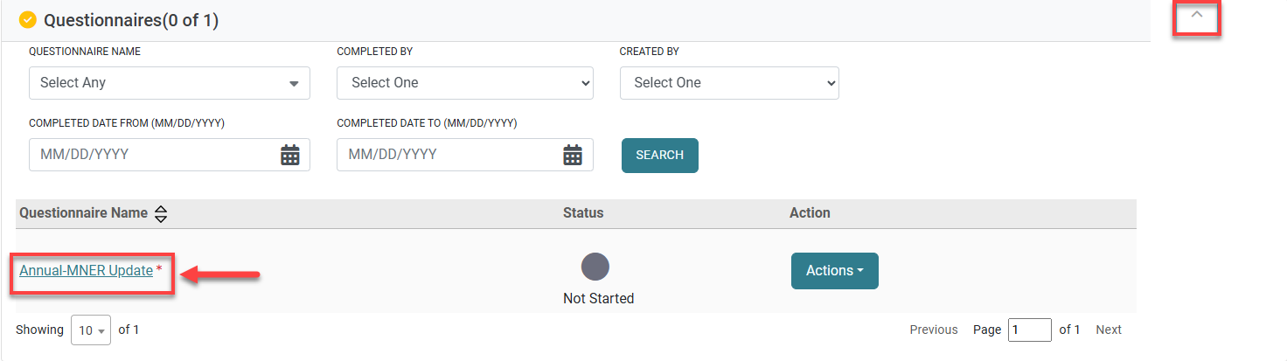
Enter demographic information and/or update if anything has changed  Note: Anything marked with an asterisk is a required field | 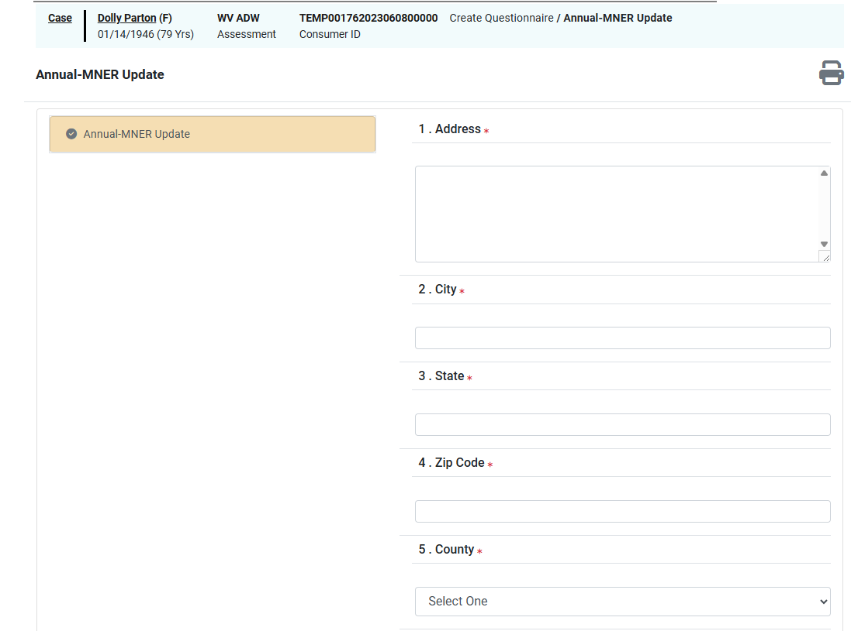
Answer the Alzheimer’s and dementia questions and any required notes in the Comments section  Ensure the left-hand panel shows a green checkmark for all sections | 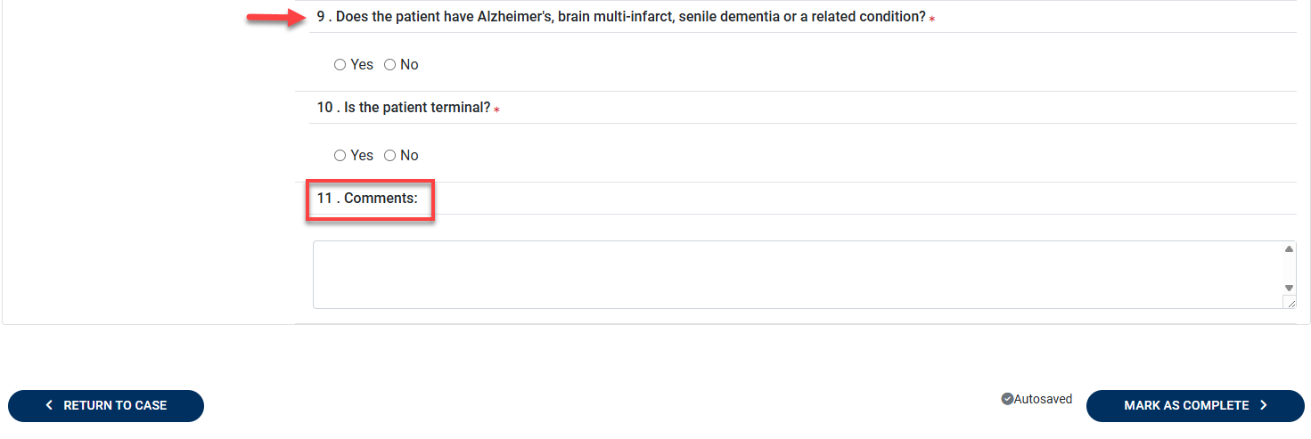  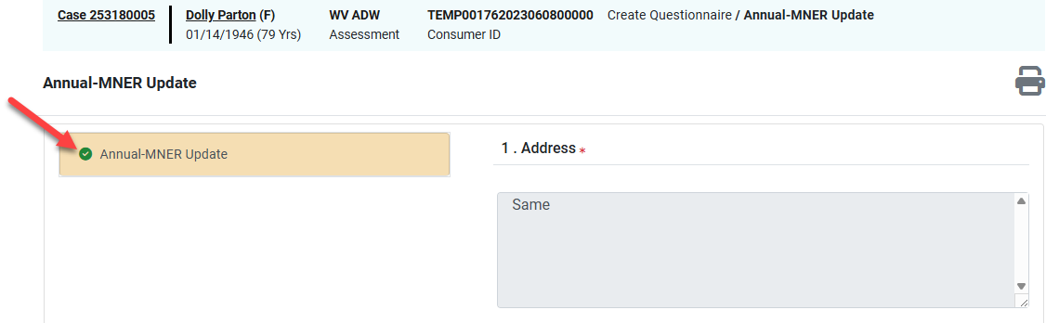
To finalize the questionnaire, click Mark as Complete | 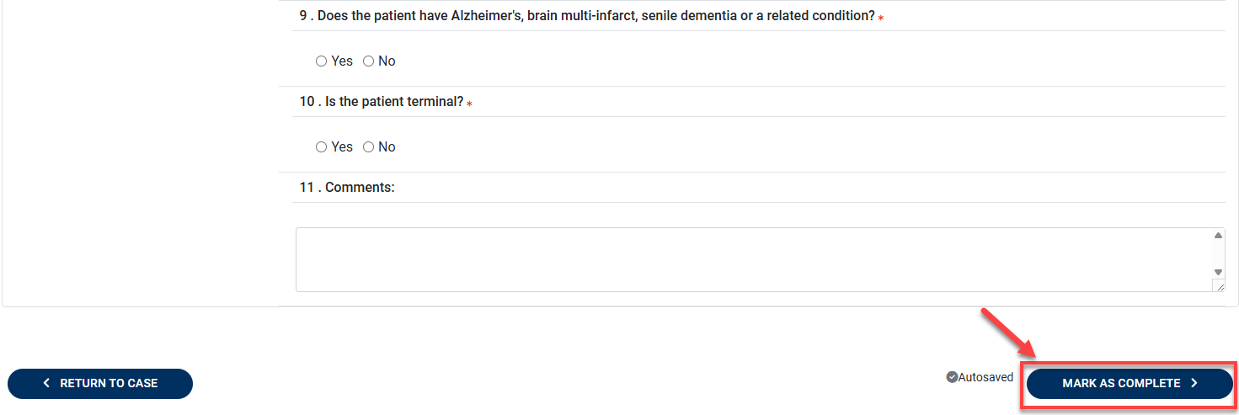
To complete the case creation, click Submit | 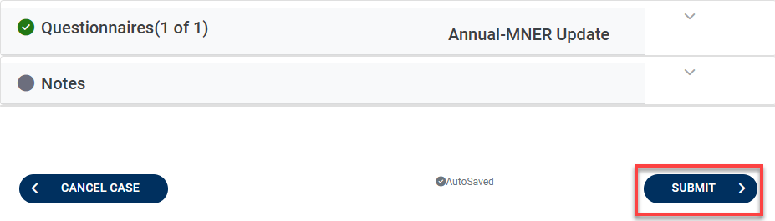
A Case ID will be generated, and the case status will be set to In-Review  Note: Record the Case ID for future use | 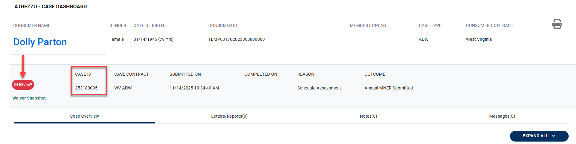

Version | Comments | Revision History | Date Updated
1 | Job Aid Created | JMulbah | 11/14/2025

