Job Aid Title: WV ADW Provider: Uploading a Document | Job Aid Number: WV.ADW.ANG.JA.009
Date Published: 11/14/2025 | Approved by: Melody Cottrell, Kim Sang
References: Atrezzo Assessment User Guide
Purpose: This job aid outlines step-by-step instructions for providers to upload documents within a case.

Consumer Search
Click the Consumers tab
Search for the consumer using Consumer ID or Last Name and Date of Birth  Click Search | 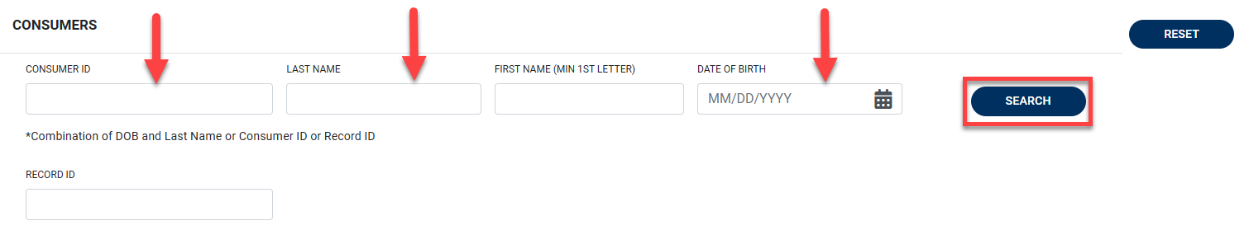
From the search results, click the name hyperlink to open the consumer’s profile | 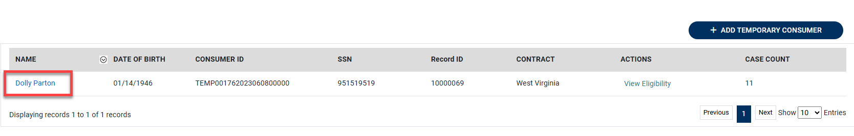
Upload Document
Scroll to the Cases section and expand it using the blue arrow |  | 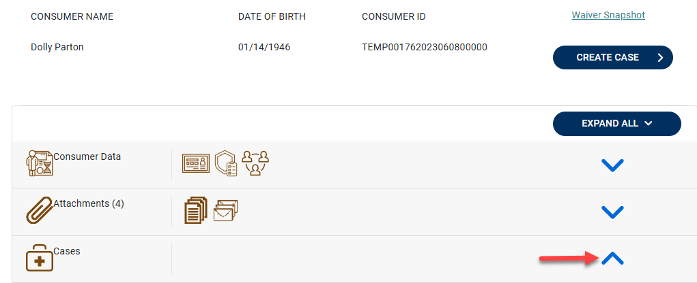

Locate the most recent ADW Assessment case  *Labeled ADW (Member Active/Medically Eligible Level _ or Verify ME_Assessment Scheduled) *  Click the corresponding Case ID to access the case | 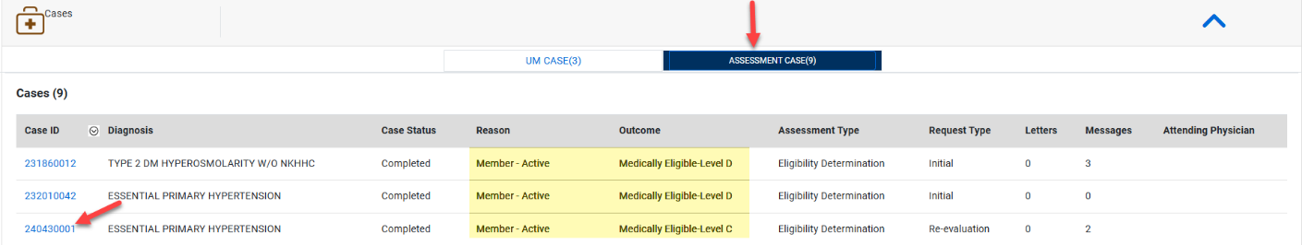
Scroll to the Documents Section under the Case Overview tab and click the arrow to expand  Select Click Here to Upload File + | 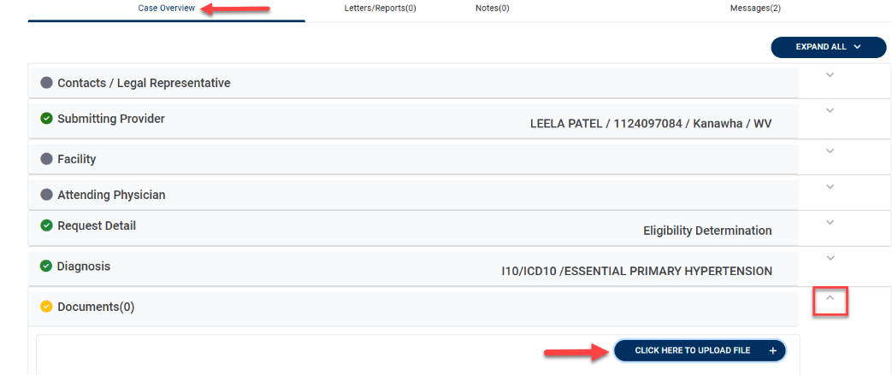
Select Browse Max File  Locate the appropriate file on your computer, then click Open to attach it | 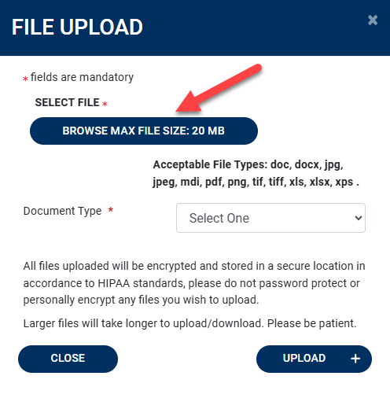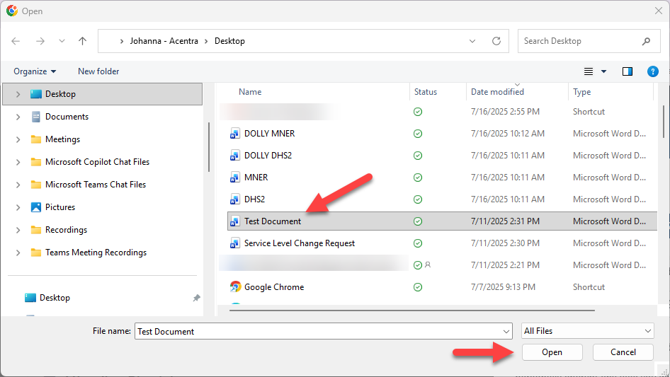
From the Document Type dropdown menu, choose the appropriate category for the file.  Click Upload + to continue | 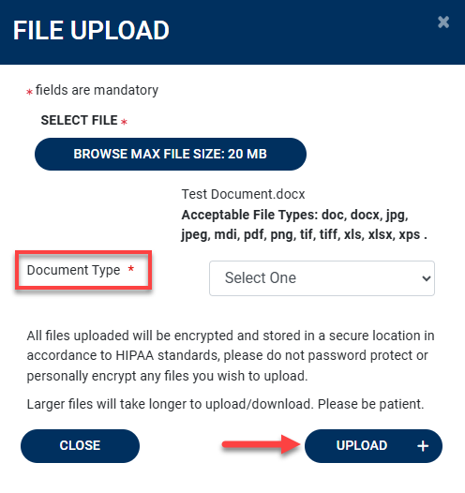
Upon successful upload, a confirmation message will appear, and the document will be automatically attached to the case | 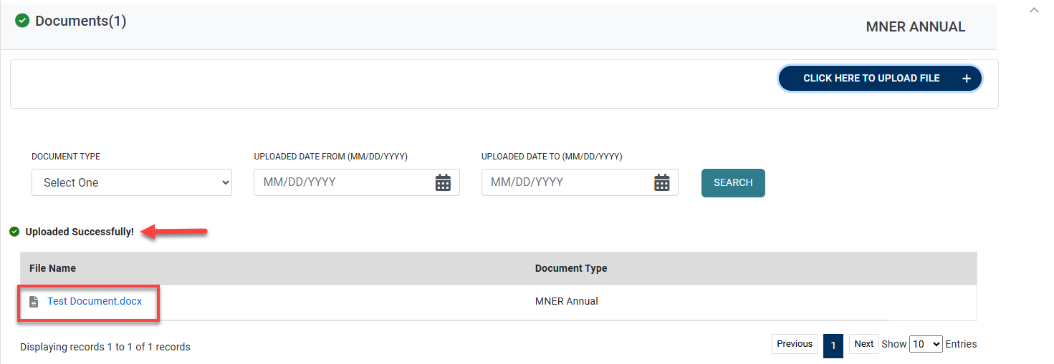

Version | Comments | Revision History | Date Updated
1 | Job Aid Created | JMulbah | 11/14/2025

